Project sheet



Project title Greening European Mobility through cascading innovation INItiatives

Project Number | 101103801
Call | HORIZON-CL5-2022-D6-02
Type of action | HORIZON-IA - HORIZON Innovation Actions
Intervention regions | Amsterdam, Copenhagen, Helsinki, Ljubljana, Munich, Paris, Porto and Turin
Leader | URBAN ELECTRIC MOBILITY INITIATIVE (UEMI) GGMBH (Germany)

Partners

- REGION HOVEDSTADEN (Denmark)
- GEMEENTE AMSTERDAM (Netherlands)
- MESTSKA CAST PRAHA 6 / DISTRICT PRAGUE 6 (Czechia)
- FORUM VIRIUM HELSINKI OY (Finland)
- 5T SRL (Italy)
- ARRIVA ITALIA S.R.L. (Italy)
- BLUEGREEN STRATEGY SRL (Italy)
- STICHTING CENEX NEDERLAND (Netherlands)
- INSTITUTO TECNOLOGICO DE ARAGON (Spain)
- PLUSERVICE SRL (Italy)
- SMART INNOVATION NORWAY AS (Norway)
- TTS Italia (Italy)
- UNIVERSIDAD POLITECNICA DE MADRID (Spain)
- DANMARKS TEKNISKE UNIVERSITET (Denmark)
- METROPOLIA AMMATTIKORKEAKOULU OY (Finland)
- TRANSPORT & MOBILITY LEUVEN NV (Belgium)
- VOLKSWAGEN AKTIENGESELLSCHAFT (Germany)
- VIA VERDE PORTUGAL-GESTAO DE SISTEMAS ELECTRONICOS DE COBRANCA SA (Portugal)
- ATOBE - MOBILITY TECHNOLOGY SA (Portugal)
- KONNECTA SYSTEMS IKE (Greece)
- VIRTUAL VEHICLE RESEARCH GMBH (Austria)
- ALLIANZ ARENA MUNCHEN STADION GMBH (Germany)
- STICHTING TOWNMAKING (Netherlands)
- CARUSO GMBH (Germany)
- EUROPEAN PASSENGERS' FEDERATION IVZW (Belgium)
- GIRO CAR SHARE D.O.O. (Slovenia)
- CLEM' (France)
- FIER BV (Netherlands)
- AIMSUN SLU (Spain)
- GOODMOOVS BV (Netherlands)
- HELSINGBORGS KOMMUN (Sweden)
- TOYOTA DANMARK AS (Denmark)
- ARRIVA DANMARK A/S (Denmark)
- PANEPISTIMIO AIGAIOU (Greece)
- A1 SLOVENIJA TELEKOMUNIKACIJSKE STORITVE DD (Slovenia)
- ASSOCIAÇÃO PORTO DIGITAL (Portugal)
- VMZ BERLIN BETREIBERGESELLSCHAFT MBH (Germany)
- YUNEX GMBH (Germany)
- TIER MOBILITY DENMARK APS (Denmark)
- RUDERSDAL KOMMUNE (Denmark)
- INLECOM INNOVATION ASTIKI MI KERDOSKOPIKI ETAIREIA (Greece)
- SIA ATOM TECH (Latvia)

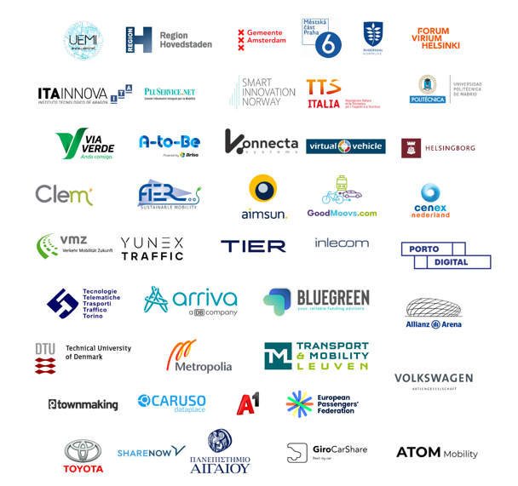

Start Date June 2023
End Date November 2026
Total attributed Budget 12 173 547,50 €

A brief description of the project

GEMINI - Greening European Mobility through Cascading Innovation Initiatives - is a project funded by the European Union under the Horizon Europe Program, involving a Consortium of 43 partners led by the Urban Electric Mobility Initiative (UEMI).

GEMINI aims at accelerating the progress towards climate neutrality through the demonstration and uptake of new shared mobility services, active transport modes, and micromobility and their integration with public transport in new generation Mobility as a Service (Maas).

GEMINI will develop and test sustainable business models for New Mobility Services (NMS), creating Mobility Living Labs (MLLs) in 8 mission cities (Amsterdam, Copenhagen, Helsinki, Ljubljana, Munich, Paris, Porto and Turin), engaging local communities in the co-creation, development and adoption of promising innovative mobility solutions with significant impact, accounting for user acceptance, sustainability and financial viability.

Communication links

https://www.geminiproject.eu/

